**Problem Statement 2: Automate YouTube: Gmail Challenge**

New video being uploaded by Internship studio on their channel (because there are multiple people to upload the video) and list all of them for sales team in an excel sheet again

**Solution →**

Step 1 Understanding:

IFTTT Account,

YouTube App and Its Account,

GMAIL Account,

Sign in Google Excel sheets

Step 2 Ideating:

We need to Connect YouTube Channel and GMAIL through IFTTT by giving Channel ID.

Step 3 Implementing:

Follow steps as Shown below.

* Open IFTTT Website.
* Click on Add

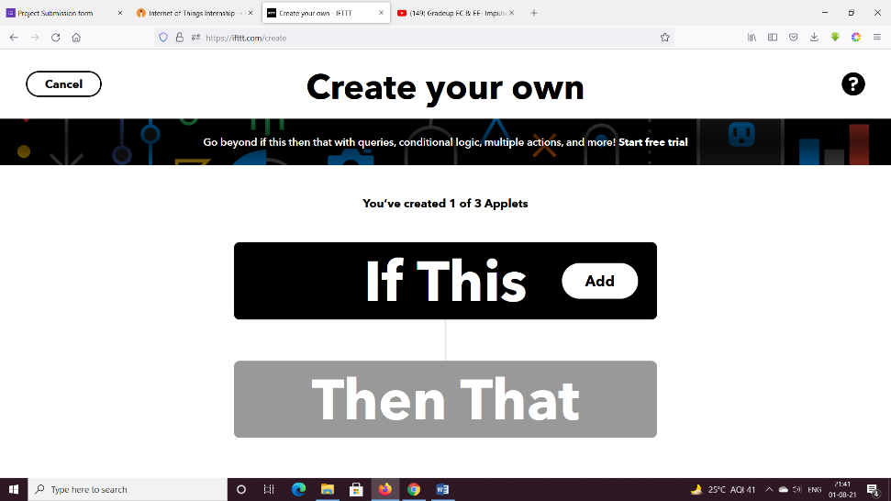

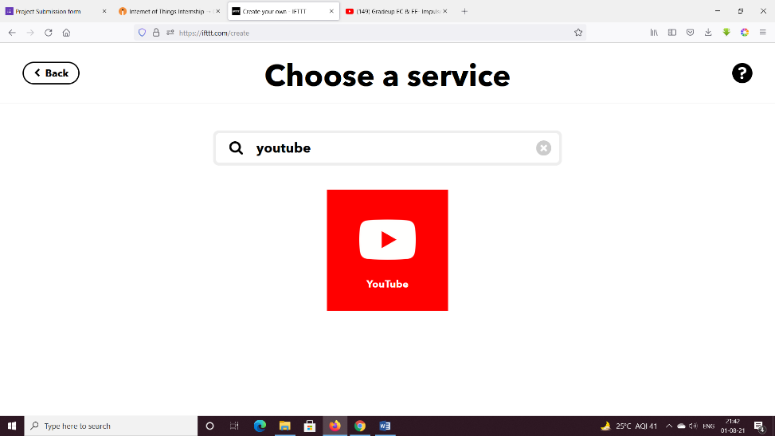

* Select new video by channel

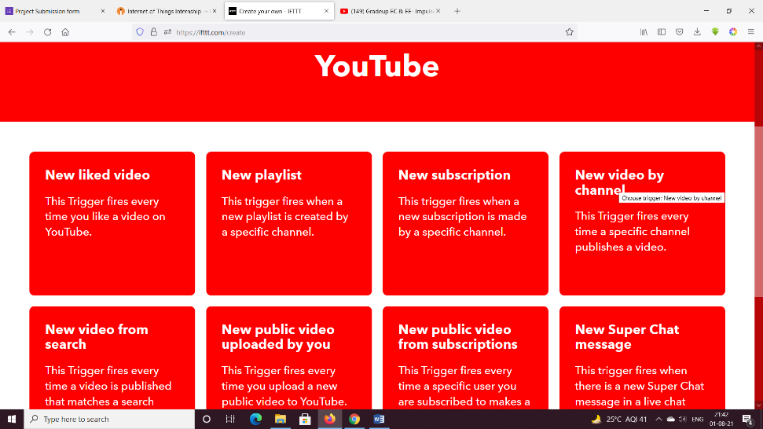

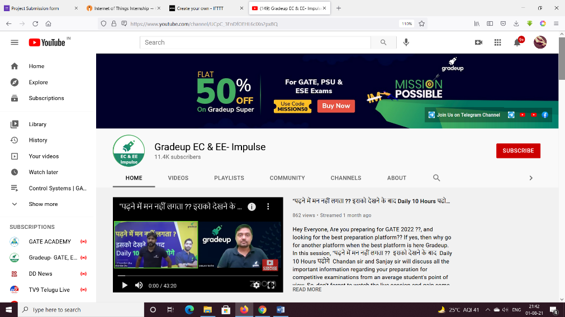

* Copy Channel ID.

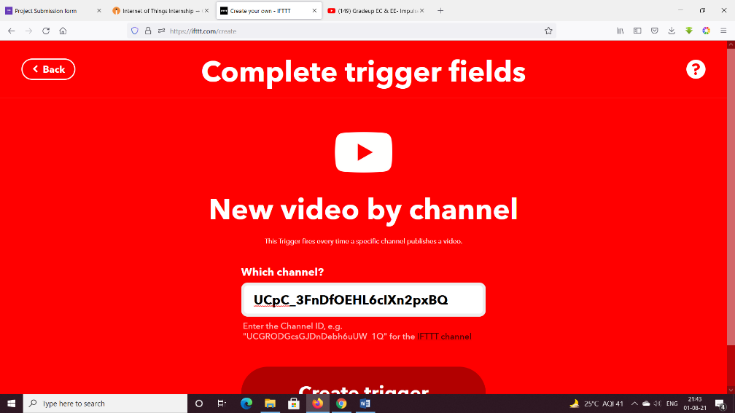

* Create Trigger

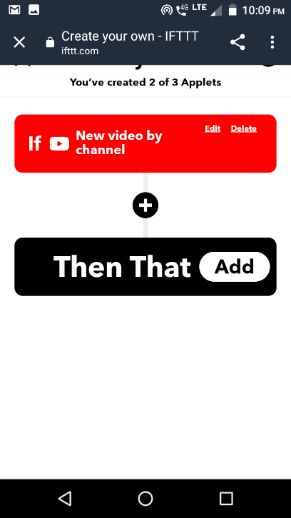

* Add Action

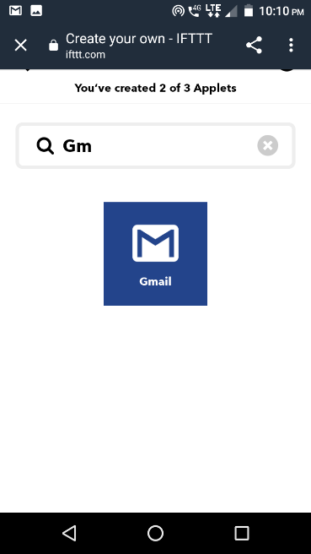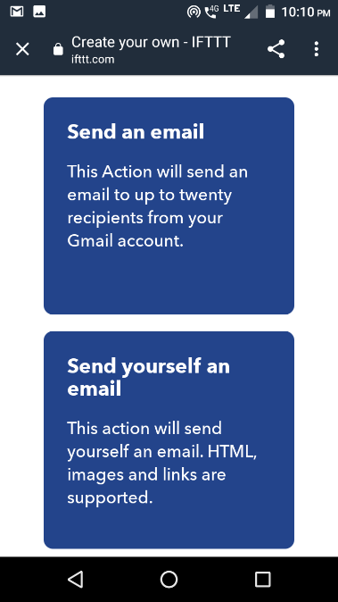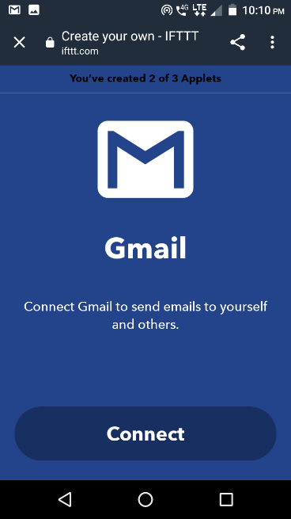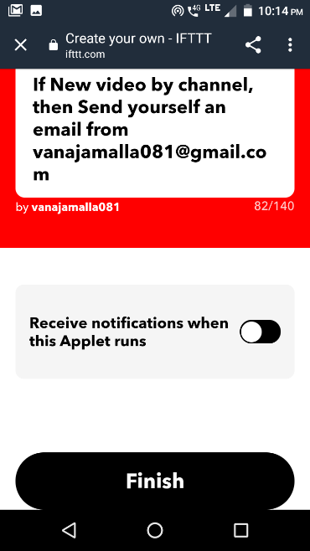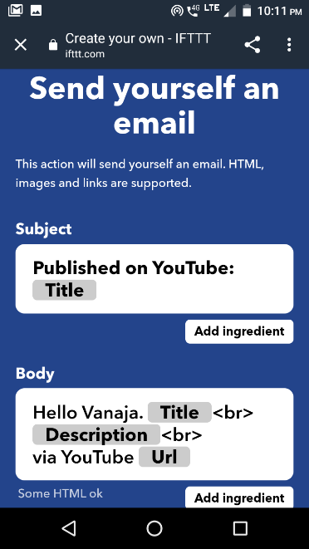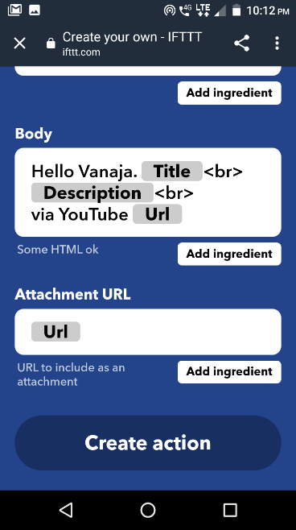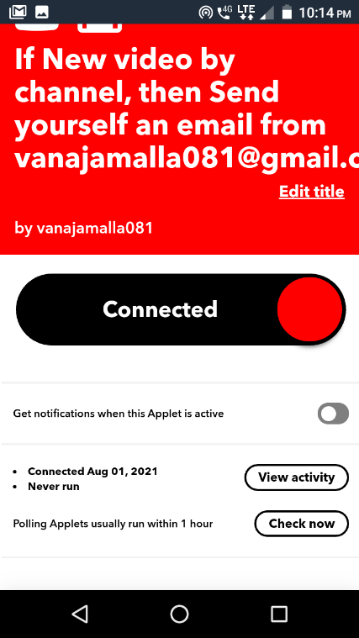

Step 4 : Final check:

* Check View activity for results.